Contents

24/8/1Generative AI Concepts 1

Introduction to Generative AI 1

Developing Generative AI Models 2

# 24/8/1Generative AI Concepts

## Introduction to Generative AI

1. Explain generative AI in simple terms.

* Generative AI is a type of artificial intelligence that can create new and original content on its own. It is like having a virtual artist or writer that can generate things like images, music, or text without being explicitly programmed for each specific output.
* Think of it as a creative machine that learns from a vast amount of data, such as images, music, or text, and then uses that knowledge to come up with its own unique creations. It can analyze patterns, understand styles, and generate new content that resembles what it has learned.

1. Provide two common examples of using generative AI in business.

* Certainly! Here are two common examples of using generative AI in business:
* **Content Generation**: Generative AI can be used to create engaging and personalized content for marketing purposes. It can generate written articles, social media posts, or product descriptions tailored to specific target audiences. This saves time and resources by automating content creation and can help businesses maintain a consistent online presence.
* **Product Design**: Generative AI can assist in product design by generating various design options based on specific criteria or constraints. For example, it can create multiple prototypes for a given product and evaluate their performance, aesthetics, or manufacturability. This accelerates the design iteration process and can lead to innovative and optimized product designs.
* These are just a few examples of how generative AI is being applied in business. Its versatility and ability to automate creative processes make it a valuable tool for various industries, enabling businesses to enhance productivity, improve customer experiences, and drive innovation.

1. Will generative AI replace all human jobs?

* Generative AI has the potential to automate certain tasks and processes traditionally performed by humans. However, it is unlikely to replace all human jobs entirely. Instead, it is more likely to augment and transform jobs by automating repetitive or mundane tasks, freeing up human workers to focus on more complex and creative aspects of their roles.

1. 生成对抗网络 (GAN) 是一种深度学习架构，它使用两个神经网络（生成器和鉴别器）来创建新的真实数据。将 GAN 想象为两位相互竞争的艺术家，一位创作假艺术，另一位试图区分真假。

<https://zhuanlan.zhihu.com/p/690903973>

* GAN 的目标是在图像、音频和文本等各个领域生成高质量、真实的数据样本。生成器网络创建新样本，而鉴别器网络评估生成样本的真实性。这两个网络以对抗的方式同时进行训练，生成器试图产生更真实的样本，而鉴别器则更擅长检测假货。

1. RLHF, GAN Architecture, Transformers Architecture

## Developing Generative AI Models

1. Factors impacting model training

* Using GPUs or TPUs decreases training time.
* Increasing the number of training rounds increases the training time.
* A more complex model architecture increases training time.

1. RLHF, Transfer Learning, Embeddings

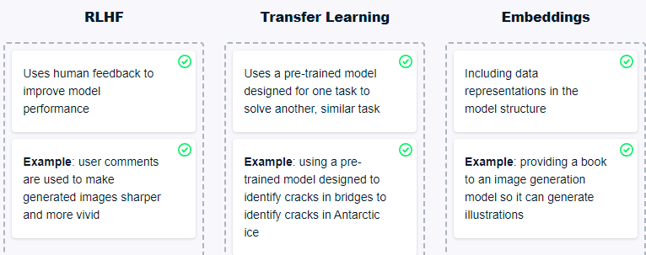

1. The Turing test requires a back-and-forth conversation between a human and the AI.